Dear Parents and Families:

Get ready! The Scholastic Book Fair is coming our way (YAY!). Choosing their own books empowers kids and inspires them to become Bolder, Prouder, and Stronger Readers. AND—as always—every book they buy earns rewards for our school.

Here’s what you need to know about the Fair, which will take place during parent teacher conferenes:
Wednesday February 28th from 3:05-8:00pm
Thursday February 29th from 1:25-7:00pm
In the ALTARA GYM

This year, we say hello to eWallet—your child’s digital payment account. Before the Fair, set up eWallet for worry-free, cash-free purchases. Anyone can contribute! Share each child’s eWallet so friends and family can add funds and give your kids more books to enjoy.

If you can’t make it to the Fair, then shop at our school’s Online Book Fair. All orders ship directly to your home, and shipping is free for book orders over $25. Your online orders will also benefit our school.

Visit our Book Fair homepage to learn more and get started with eWallet and online shopping:
https://www.scholastic.com/bf/altaraelementaryschool2

The countdown to more Bookjoy is on! Catch you at the Fair!

Happy reading,

Julie Fielding
Principal
Altara Elementary School

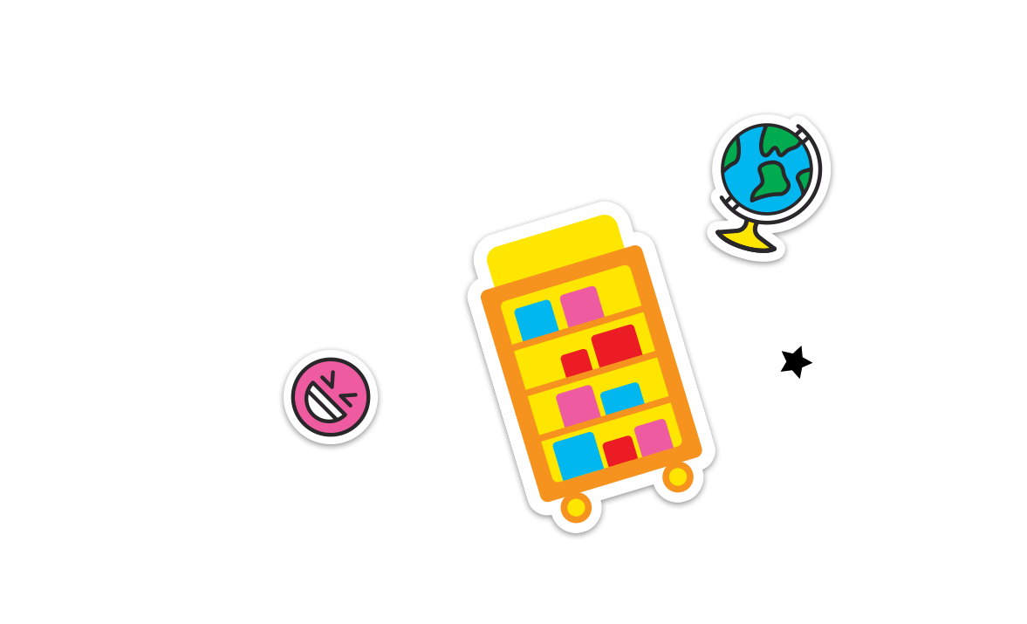
Permission to reproduce this item is granted by Scholastic Book Fairs®.
©2022 Scholastic Inc. All rights reserved. 2580250 F22 • 2580301

